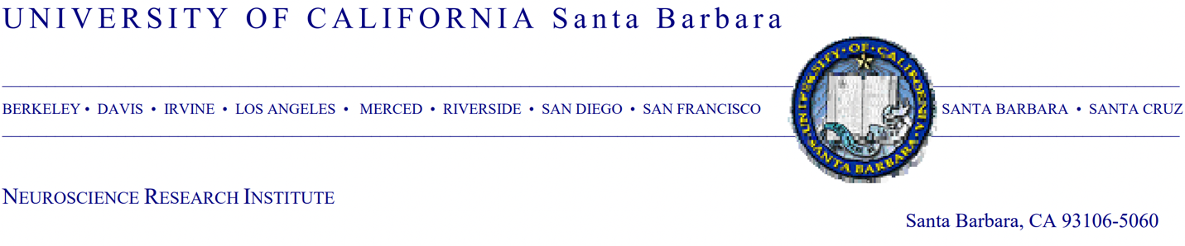

Dr. Alexandra Le Bras, PhD

Chief Editor

*LabAnimal* journal

January 17, 2023

Dear Editor,

We would like to submit our manuscript entitled, “Plasma metabolomics supports non-fasted sampling for early detection of impaired glucose tolerance in the Nile rat model of type 2 diabetes” by Anderson *et al.* for your consideration to be published in the *LabAnimal* journal. In this manuscript, we evaluated sampling Nile rat plasma under non-fasted versus fasted conditions. We found that sampling in the non-fasted state gave lower variance in metabolite abundance and yielded more biomarkers associated with glucose tolerance than the fasted state sampling.

Given the need for improved animal models in type 2 diabetes, we believe that the findings in our manuscript will appeal to the readers of *LabAnimal*. The outbred, diurnal Nile rat is an emerging model for type 2 diabetes with key benefits. The etiology of diet-induced diabetes in the Nile rat closely resembles human type 2 diabetes, where calorie overload coupled with low fiber (conventional rodent chow diet) is sufficient to cause diabetes in both sexes. The progression of diet-induced diabetes in the Nile rat occurs more quickly than in obesity-induced mouse models, reducing need for longer studies. Additionally, molecular tools are now being developed for the Nile rat based on the newly available reference genome, which will enable researchers to apply molecular strategies for validation studies.

One of our lab’s goals is the development of methods to facilitate diabetes research with the Nile rat model. In this study we established a method for sampling blood plasma to study metabolic changes during progression to diabetes. We developed metabolomics methods that need only 5 µL of plasma, yielding metabolite identifications similar to methods using 20-100 µL. This small amount enables studies in young animals undergoing frequent sampling. With this method, we evaluated triplicate fasted and non-fasted state plasma samples collected weekly from young Nile rats. To discover metabolite associations to glucose tolerance, we used a dual machine learning approach with individual metabolite linear regression and multivariate regression. Unlike the commonly used method of binary prediction of +/- diabetes, the regression against a continuous value better reflects the spectrum of glucose tolerance. Given that diabetes is not an on/off switch, our machine learning methods will be relevant for other continuous values used for assessing diabetes.

Our findings support the use of non-fasted sampling for metabolomics studies, which also simplifies animal handling and is rich in diabetes-relevant biomarkers. With these methods, we aim to fill the knowledge gap on early diabetes progression.

We recommend the following reviewers: Charles Evans (University of Michigan)  [chevans@umich.edu](mailto:chevans@umich.edu) and Lily Yan (Michigan State University) [yanl@msu.edu](mailto:yanl@msu.edu).

Thank you for your consideration of this manuscript.

Sincerely,

Dr. Huishi Toh, PhD

Assistant Project Scientist, Department of Neuroscience Institute

University of California, Santa Barbara